Press release

MetalDecoJET about to start production in Spain
  - Spanish metal decorating specialist Litalsa is the first commercial user
- Successful handover for production
- Designed for industrial production conditions
- Food-safe, non-toxic water based inks
Stuttgart, 23.7.2019
Spanish metal decorating specialist Litalsa works with the world's largest packaging manufacturers, providing high quality services of offset printing and coating of metal sheets that customers subsequently transform in a grand variety of products: from the traditional tin cans for preserved food to aerosols, decorative containers, and twist off caps or crowns.
Looking for ways to handle the ever-increasing variety of different jobs while reducing batch sizes and providing customers with the services necessary to shorten their time-to-market, Litalsa CEO Juan Inchausti and his printing and prepress specialists looked for digital press vendors that could meet the high demands of the metal packaging industry.
It soon became clear that there was no lack of print quality itself - many suppliers offered high quality printing - but the processing properties of UV inks were a constant source of problems: ink layers up to 10 times thicker than in offset printing, rough surfaces that needed to be covered with additional coating passes, cracking inks that could fall off and contaminate the food in the containers to be produced, lack of food conformity and temperature stability of the pigments, and so on.

Food Safe, non-toxic water-based inks
For Litalsa, it was also a surprisingly new approach to digital printing on packaging sheet that metal decoration specialist Koenig & Bauer MetalPrint presented at METPACK 2017: the use of food-safe, non-toxic, water-based inks on non-absorbent substrates combined with a machine design suitable for industrial production conditions.
After reviewing print samples and thoroughly testing the MetalDecoJET machine concept, one of its outstanding features being that it is perfectly adapted to the sheet formats commonly used in metal decorating, Litalsa decided to enter into an agreement with Koenig & Bauer MetalPrint to become the first commercial user of this unique water-based inkjet technology.
In the coming months, the digital printing unit presented at the show was expanded into an industrial production line consisting of automatic feeder, pre-treatment, printing, drying and stacking systems, making it the first digital printing system dedicated to the metal decorating market.
During this design phase, the development team around Product Line Manager Rainer Simon worked intensively on further improving print quality and stabilising the process parameters that ultimately determine the productivity of such a system.
This work was rewarded with the successful factory acceptance test at the end of 2018 in Stuttgart, where CEO Juan Inchausti and prepress manager David Valencia rated the print quality of more than 10 different jobs as comparable to offset printing and thus as saleable production.
The high print quality and good processing properties recently attracted attention elsewhere as well: on behalf of thyssenkrupp Rasselstein, Pirlo Verpackungen and Koenig & Bauer-MetalPrint produced digitally printed snap-on lid cans for the participants at the Rasselstein Future Symposium 2019.

Successful handover for production
But back to the Spanish model company Litalsa. After the successful factory acceptance test, preparations were made in Oyon for the delivery and installation of the MetalDecoJET, so that the team from Stuttgart could quickly set up and commission the production line. At the beginning of July, the line was handed over to the customer for production.
Koenig &Bauer printing engineer Manuel Weiler is familiarising David Valencia's prepress team with the operation of the machine and the handling of the print data. For example, jobs currently running on the offset presses are additionally printed on the MetalDecoJET in order to work out and document the necessary adjustments in the color management and digital workflow that have been practised to date.

Impressive results
And the results are impressive: For the customers who are also guided to MetalDecoJET as part of the factory tour through the exemplarily organised Litalsa factory, it is often impossible to distinguish between digital and analog production, especially due to the offset-like ink application.
This comparability is also what allows Litalsa to use MetalDecoJET for its customers' pre-series production and marketing campaigns, where it is essential in the design phase to immediately inspect designs on the metal sheet, implement design changes at lightning speed and then print them in small runs. After the successful field test, the layouts can then be transferred to conventional offset presses without any problems. In this way, the customer's MetalStar3 is fully available for volume jobs and is no longer slowed down by the numerous make-ready and start-up processes.
It will be interesting to see how Litalsa's customers accept this new offer and take advantage of the flexibility it brings. In any case, we assume that the marketing specialists are already in the starting blocks to implement individualisation or mass customisation applications together with Litalsa on the MetalDecoJET that were previously impossible in metal decorating.

Photos
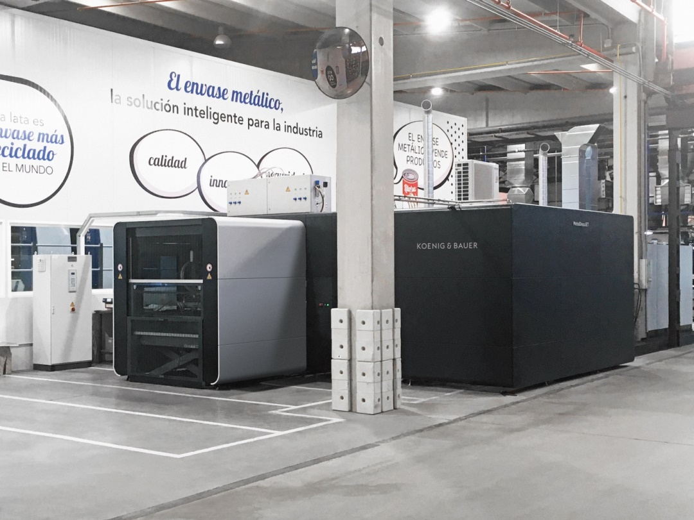
The first installed MetalDecoJET at Spanish metal decorating specialist Litalsa.
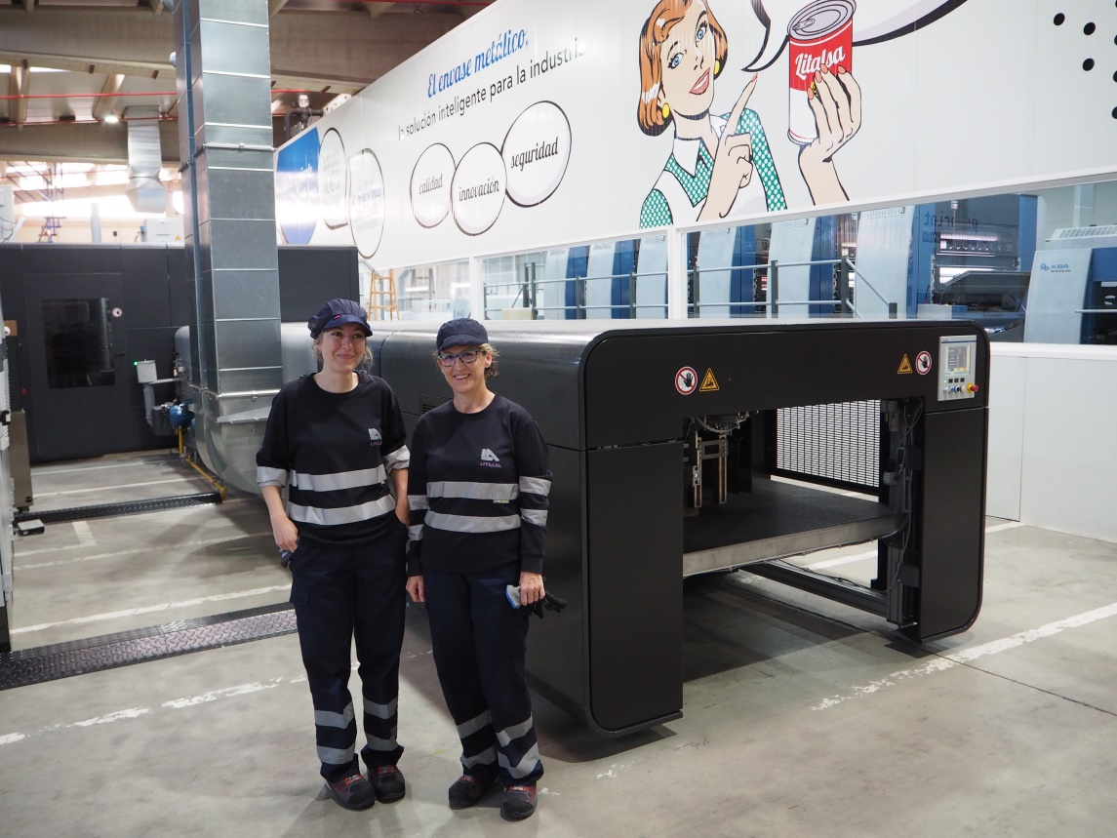
Photo 2

The two printers are currently being trained at MetalDecoJET.
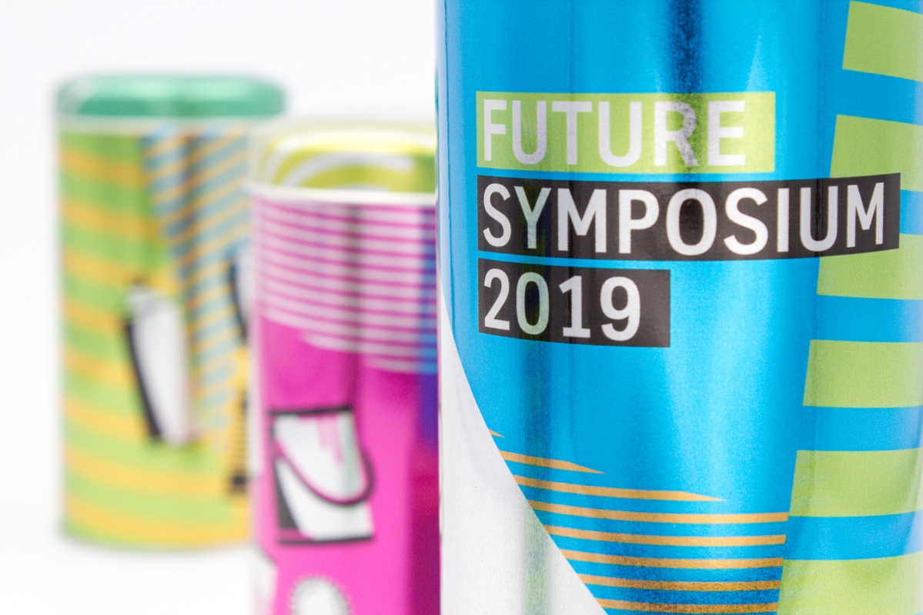
Digital printed lid cans for the Future Symposium at Thyssen Krupp Rasselstein.
Contact person for the press
Koenig & Bauer MetalPrint GmbH
Ursula Bauer
Marketing & Corporate Communications
T +49 711 69971-859
M ursula.bauer@kba-metalprint.de

About Koenig & Bauer
Koenig & Bauer is the oldest printing press manufacturer in the world with the broadest product range in the industry. For more than 200 years, the company has been supporting printers with innovative technology, tailor-made processes and a wide array of services. The portfolio ranges from banknotes, via board, film, metal and glass packaging, through to book, display, coding, magazine, advertising and newspaper printing. Sheetfed and webfed offset and flexo printing, waterless offset, intaglio, simultaneous perfecting and screen printing or digital inkjet – Koenig & Bauer is at home in virtually all printing processes and is the market leader in many of them. In the financial year 2018, the approximately 5,700 highly qualified employees worldwide generated annual sales of more than EUR 1.2 billion.
Further information can be found at www.metalprint.koenig-bauer.com
www.koenig-bauer.com

